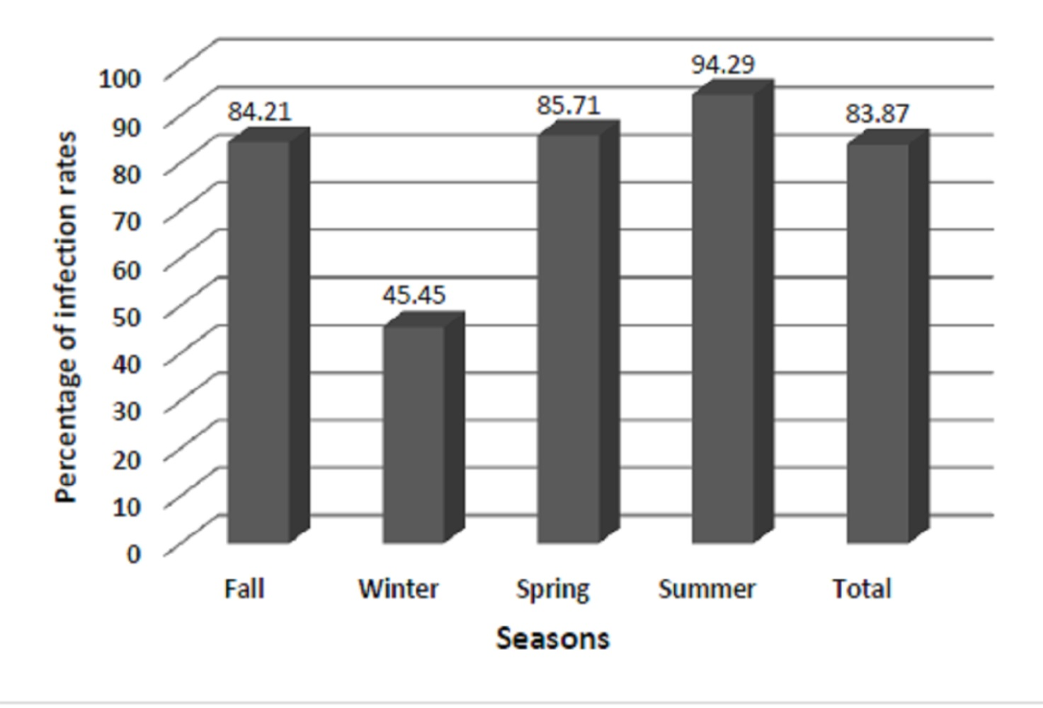
Figure . The leishmanial infection of rodents. The leishmanial infection rates of rodents in different seasons using nested-PCR assay, Segzi area, Esfahan Province, October 2016-October 2017

